

**ASSIGNMENT:LAB SHEET 2**

***Waqas Ashiq.***

***Bcs-f11-201.***

***Section c.***

***Submitted to: Sir Bilal Hassan.***

***Q#1:***

***(Comparing integers)***

#include<stdio.h>

int main()

{

int x,y;

printf("enter the numbers=");

scanf("%d%d",&x,&y);

if (x>y)

{

printf("%d is larger than %d\n",x,y);

}

if(y>x)

{

printf("%d is larger than %d\n",y,x);

}

else if (x=y)

{

printf("%d is equal to %d\n",x,y);

}

return 0;

}

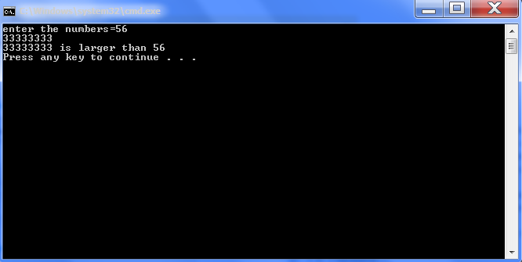

***Q#2:***

***(Largest of ten entered integers)***

#include<stdio.h>

int main()

{

int counter=1,number,largest=0;

while(counter<=10)

{

printf("enter the number %d:\t",counter);

scanf("%d", &number);

if(number >largest)

{

largest = number;

}

counter++;

}

printf("the largest number is %d\n", largest);

printf("\n\n\n");

return 0;

}

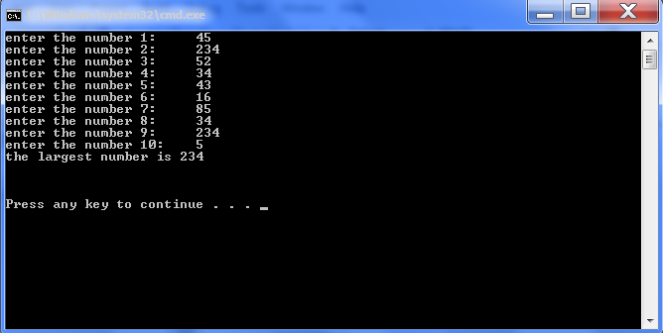

***Q#3:***

***(Largest and second largest form ten entered integers)***

#include<stdio.h>

int main()

{

int counter=1,number,largest1=0,largest2=0;

while(counter<=10)

{

printf("enter the number %d:\t",counter);

scanf("%d", &number);

if(number >largest1)

{

largest1 = number;

}

else

{

if(number<largest1 && number>largest2)

{

largest2 = number;

}

}

counter++;

}

printf("the largest number is %d\n", largest1);

printf("the second largest number is %d\n",largest2);

printf("\n\n\n");

return 0;

}

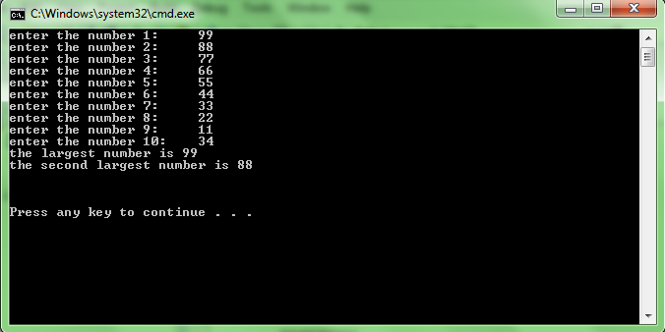

***Q#4:***

***(Sentinel while loop)***

#include<stdio.h>

int main()

{

int grades,pass=0,fail=0,counter=0;

printf("enter the grades or press -1 to end:\t");

scanf("%d",&grades);

while(grades != -1)

{

if (grades >= 60)

{

pass++;

}

if (grades <60)

{

fail++;

}

printf("enter the next grade or -1 to end:\t");

scanf("%d",&grades);

}

printf("the number of pass students is %d\n",pass);

printf("the number of fail students is %d\n",fail);

return 0;

}

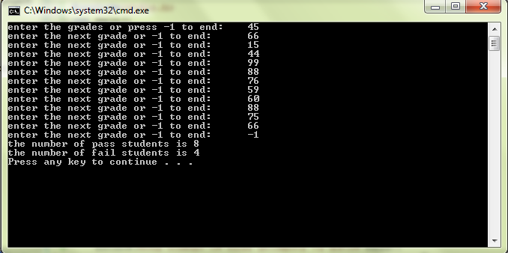

***Q#5: (Switch)***

#include <stdio.h>

int main()

{

int color = 1;

printf("Please choose a color( red=1,green=2,blue=3):\t");

scanf("%d", &color);

switch (color)

{

case 1:

printf("\nyou chose red color\n");

break;

case 2:

printf("\nyou chose green color\n");

break;

case 3:

printf("\nyou chose blue color\n");

break;

default:

printf("you did not choose any color\n");

}

printf("\n\n\n");

return 0;

}

